Go to the **VCSS website** → **https://vcss.ocfo.gsa.gov**

Click on the “**System Login**” button.

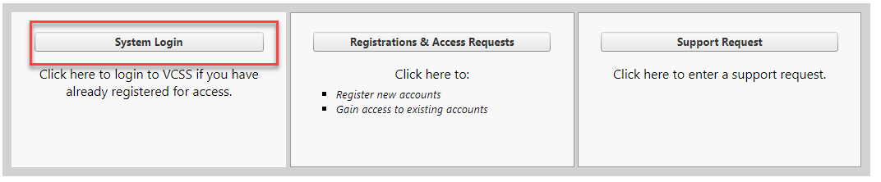

Click on “Accept & Continue

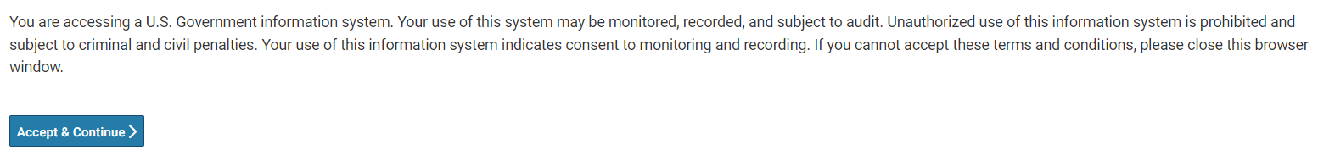

Go to the right corner, and drop down arrow, Select SIGN ON

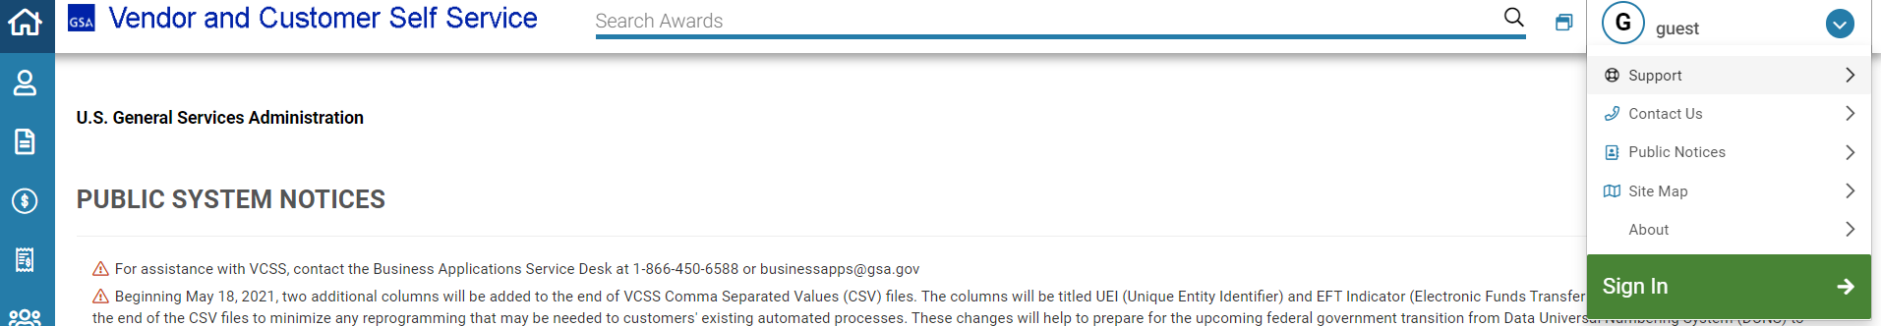

​Sign in with your User ID and password

Click on the “**Statements**” icon that appears as a page with the upper right corner folded and choose the “**View and Print Statements**” sub-menu item.

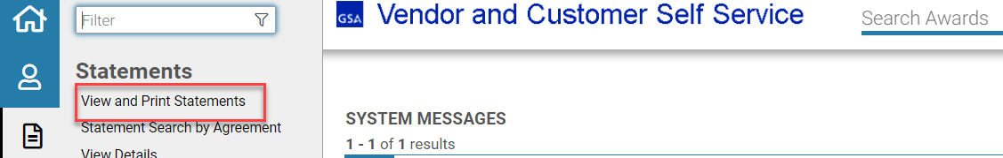

You can use any of the “Search Criteria” fields to perform the search. The most used is “Account code” (Vendor Code) or “Agency Location Code” (ALC) by which you want to view the statements/bills. *Note: As you begin to search, the system will provide the list of accounts with that set of characters. Then click “Search”.

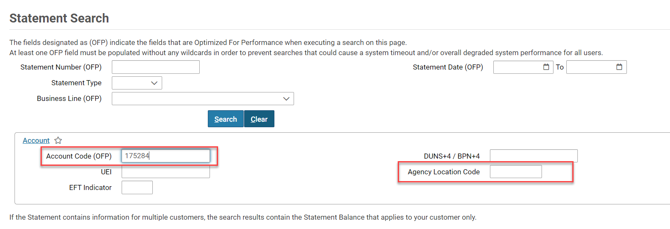

You will be presented with a list of all bills/statements for that Account Code or ALC. You may also have multiple pages of bills/statements; you can sort these in ascending or descending order by clicking on any of the column headings.

*Note: You can only view one bill/statement at a time. To download multiple statements, please repeat the following steps for each bill/statement you need to save/print.

To view, select the radio button next to the bill/statement, and click the “**View PDF**” button.

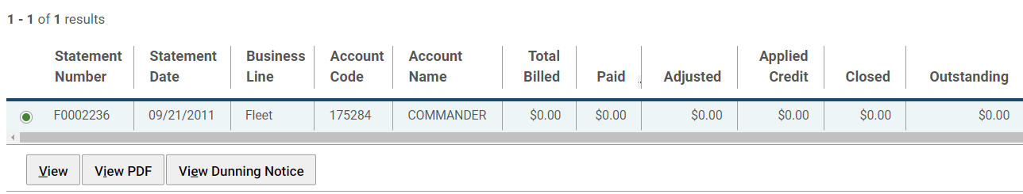

Your browser will refresh and, depending on your browser security settings, will indicate how to download the PDF file.

The most common steps will be for Internet Explorer to have a yellow pop-down window, stating that it is blocking the file from downloading to protect your security. Right-click on this message bar, and choose “**Download File …**”

You will then get an error message; click “**Retry**.”

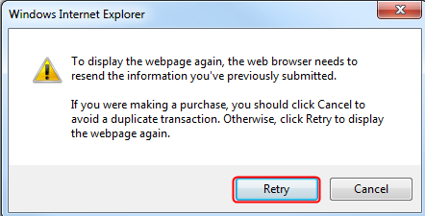

Choose “**Open**” or “**Save**."

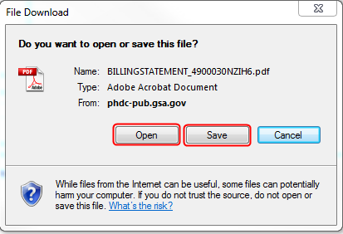

Once opened in Adobe, you can view, print and save the file.